3. Specific Requirements
3.1 External Interface Requirements
3.1.1 User Interfaces
In this section of the document is presented the UI of CodeKataBattle platform: the views both the Student and the Educator are going to see when using the web application.
A Students or an Educator needs to sign in to access the site, if he/she doesn't have registered, the last one can sign up:
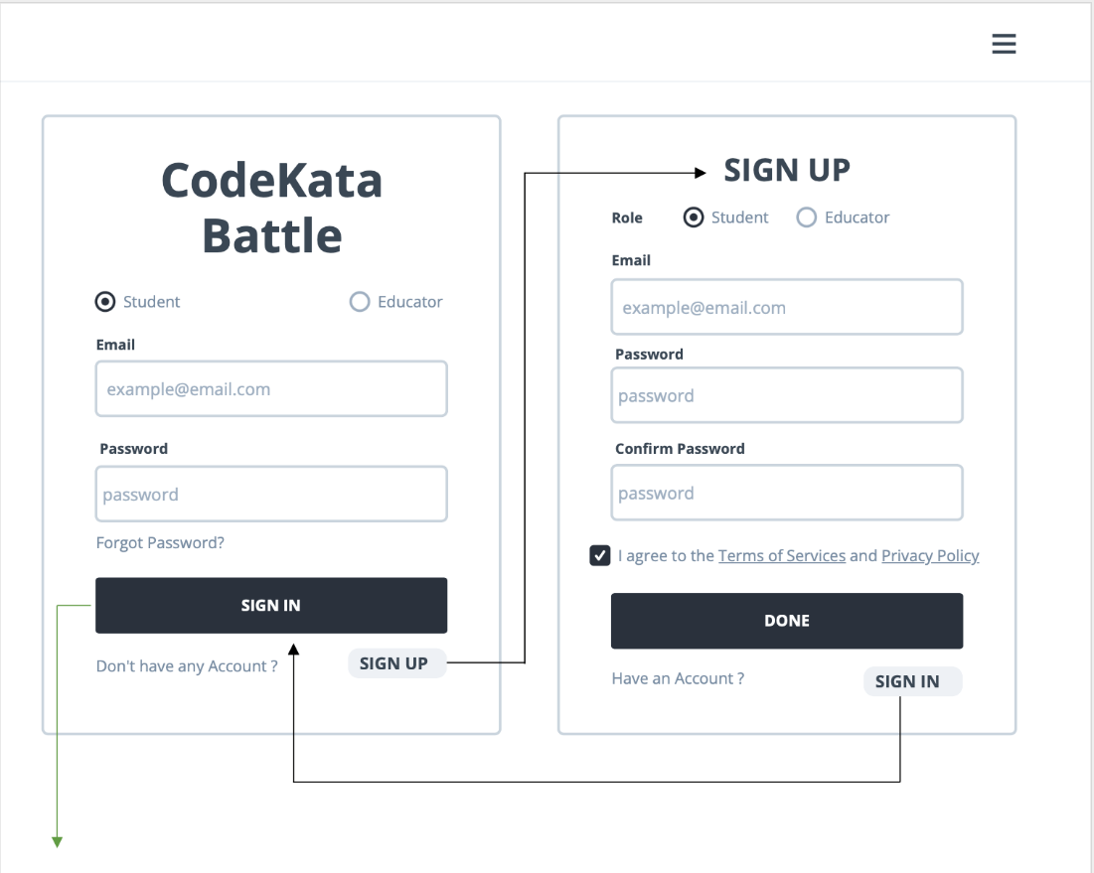
Once is logged in, he/she can see the homepage: there's all sorts of information about tournaments and battles available, as well as times and awards:
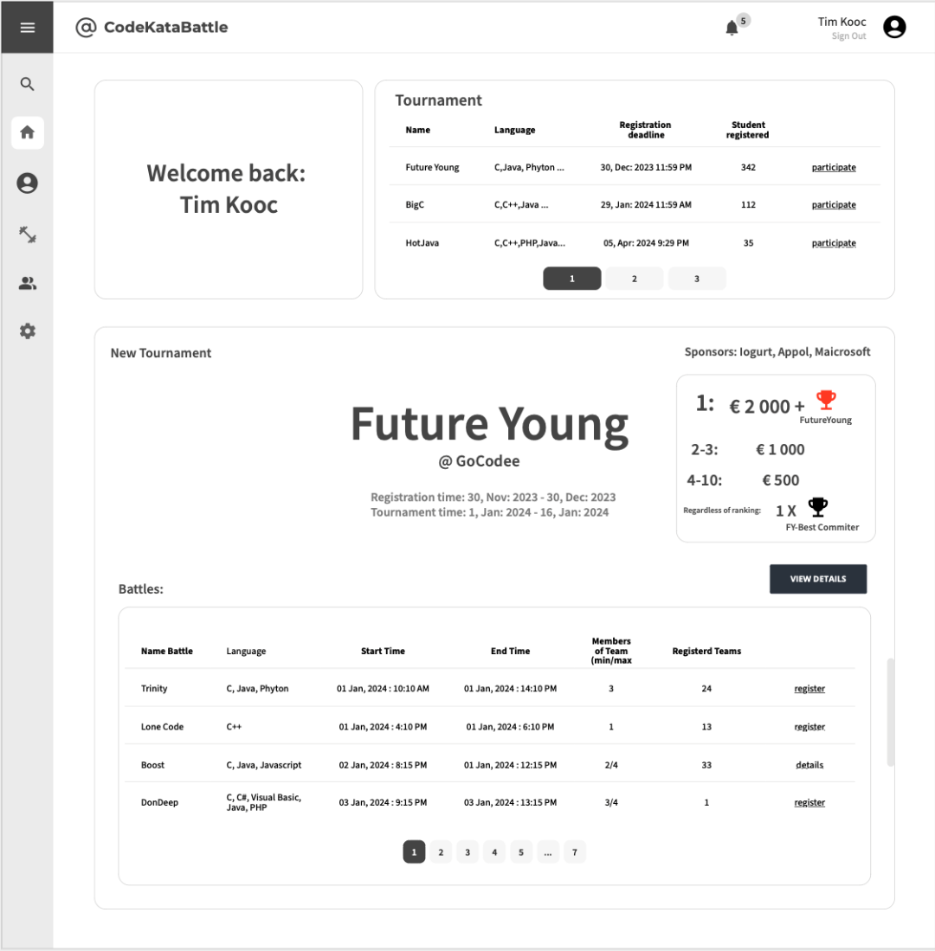
Of course, he/she can also find more information from his personal information, such as the overall ranking of the Student at CKB, scores, tournaments and battles participated in, personal titles, and battles to be participated in:
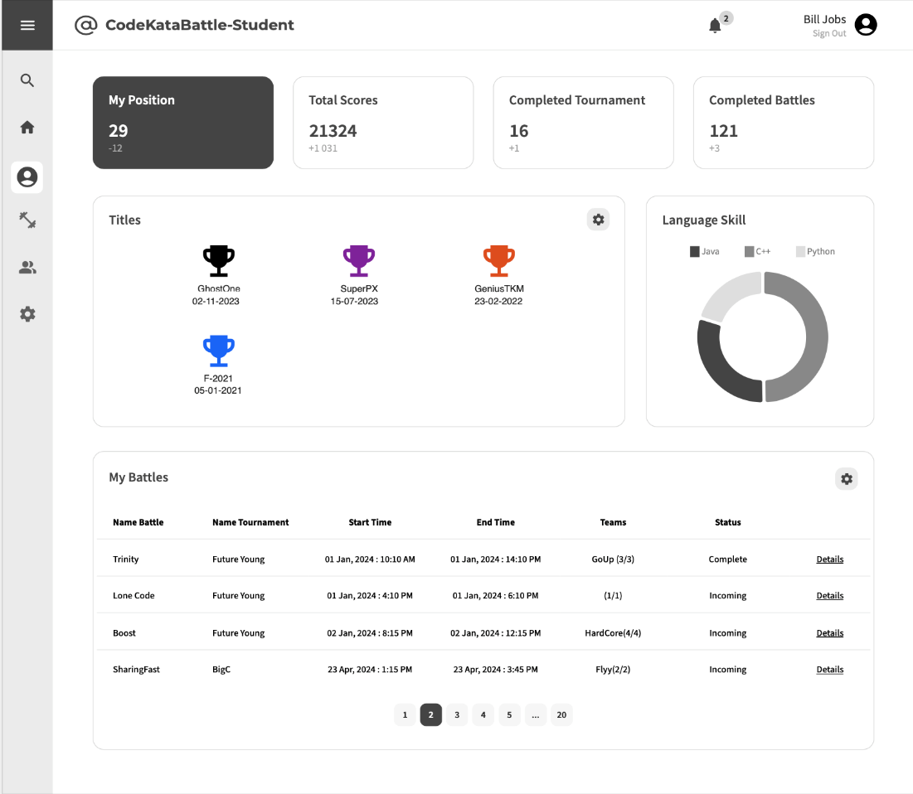
On the Educator's side, it is possible to: view created battles or tournaments, battles awaiting results, and upcoming battles; in addition, the Educator can create a new battles or tournaments：
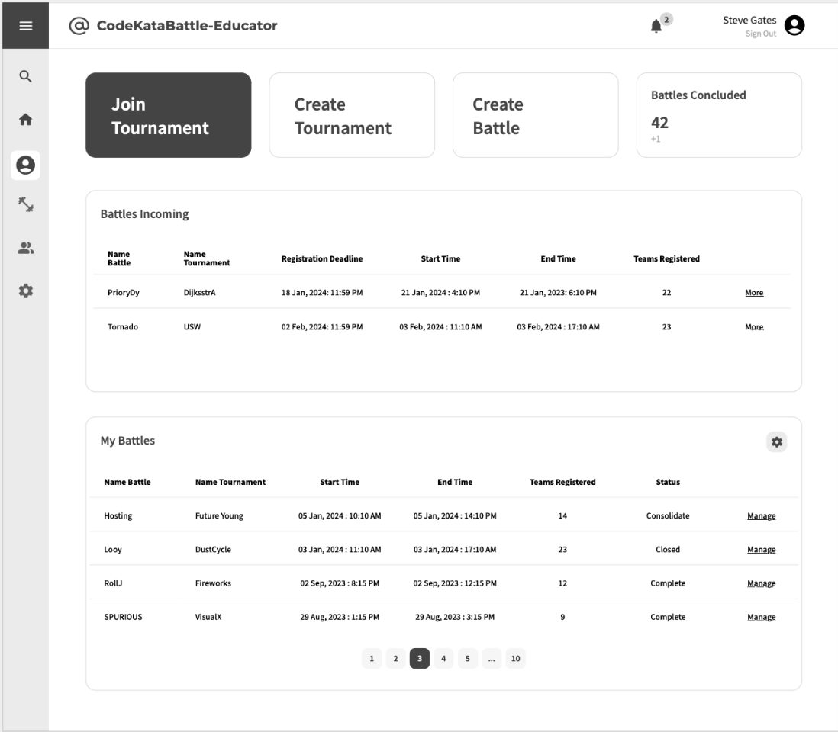
During the creation process, he had many options to choices to complete the creation:
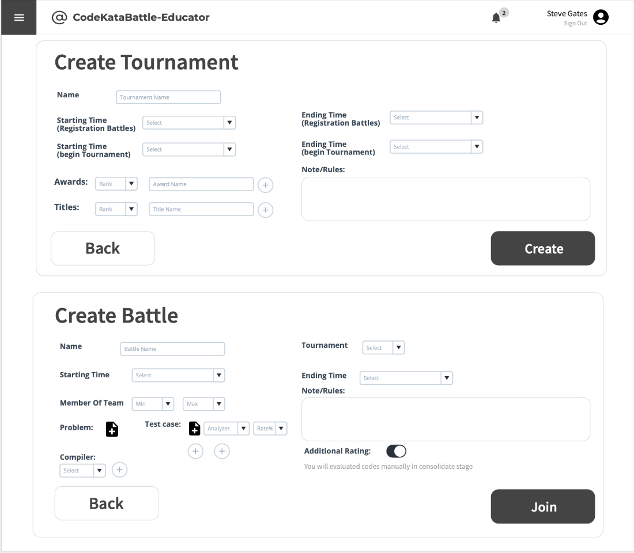
When the battle starts, the student can see assignment, scores, ranking, remain time; he/she can also click to “leave” button for a while if he has other Battle:
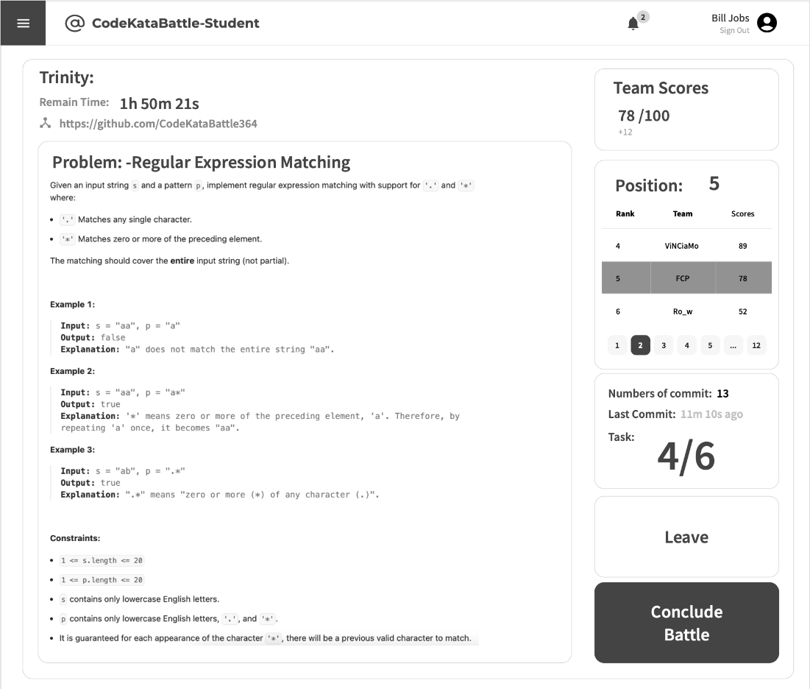
At the end of the tournament (Consolidation Stage), Educator can refer to the students' code and can run and evaluate it:
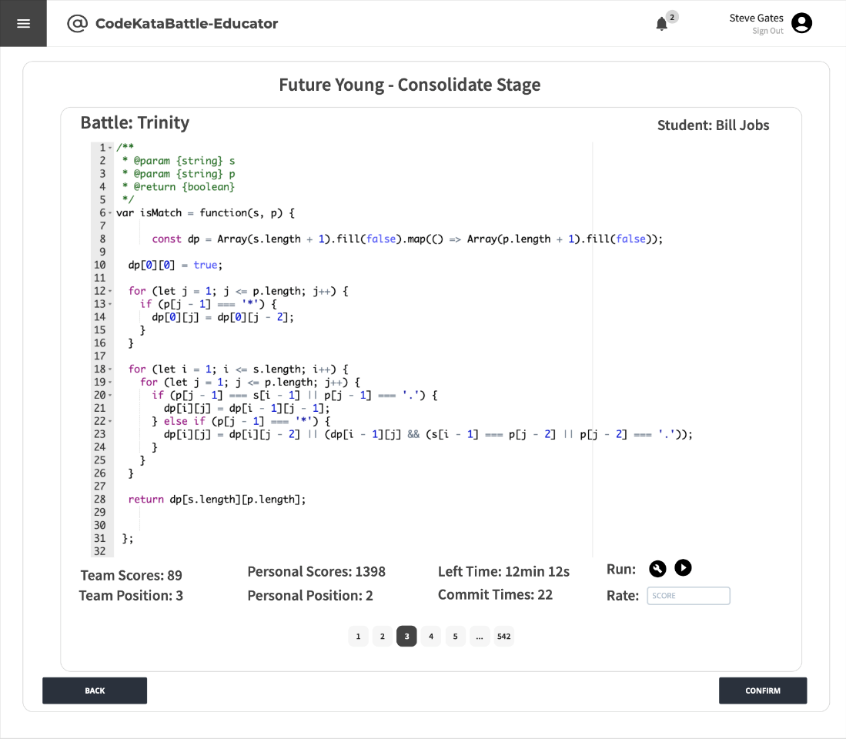
At the end, students can see the final rankings：
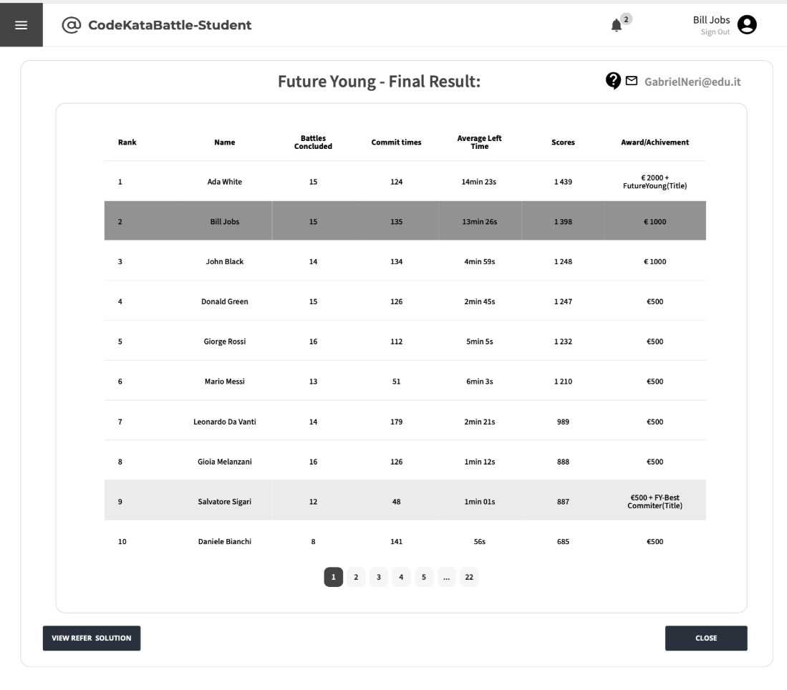
In additional, students are free to practice past tournaments (with corresponding battles):
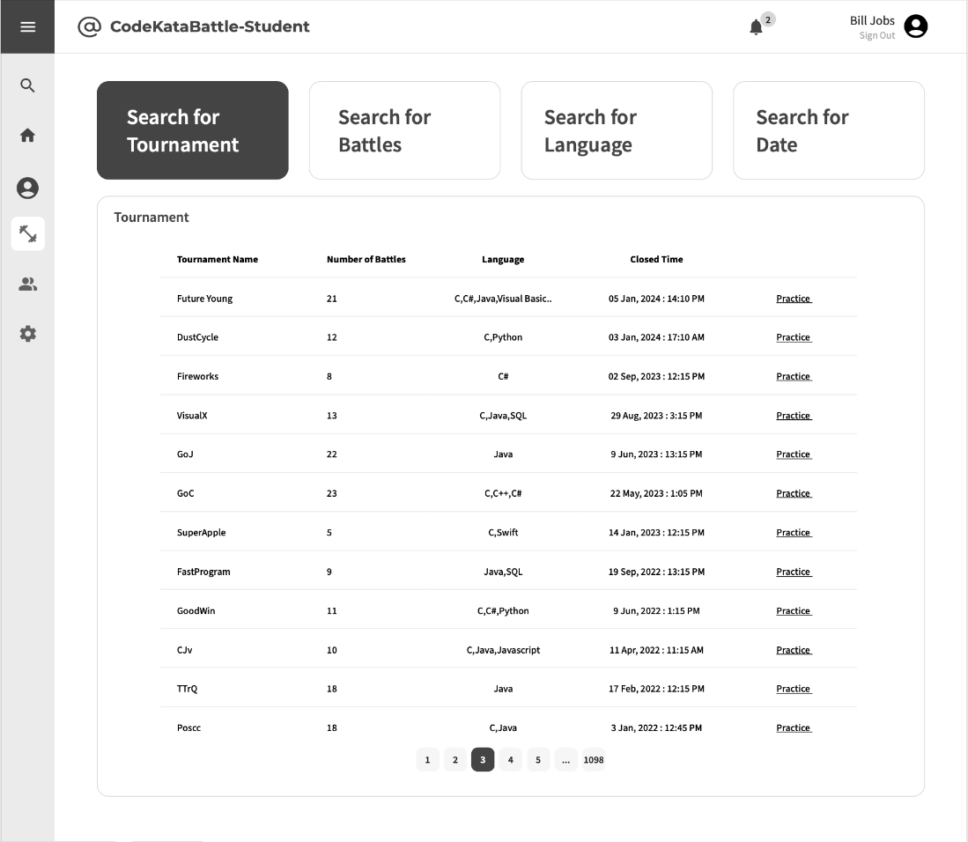
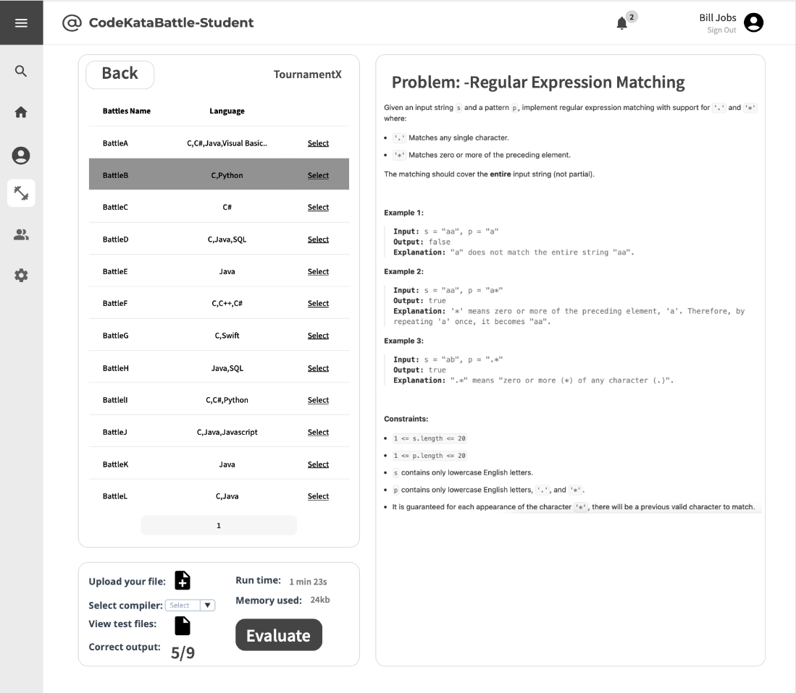
3.1.2 Hardware Interfaces
The service offered by the System via the computer with internet connection and possible mobile device which can also connected with internet.
3.1.3 Software Interfaces
The System required several software interfaces to provide its services:
- Online compilers, provide Users to write, compile and run code directly in their browsers without the need for local development environments
- Statistical analysis tools, the System provides to Educators and/or Students to assess the quality of source code by examining various aspects
- GitHub API, provide services by GitHub to allow User to programmatically interact with GitHub’s features and data, such as: accessing user information, collaborate code with other Users etc.
3.1.4 Communication Interfaces
The system exploits the internet connection for the communication to and from all personal computer and/or laptop of the Users with possible mobile devices.

3.2 Functional Requirements
The following specifies all the requirements that the system must fulfil to function properly:
Requirement | Description
R1 | The system allows Students to sign up.
R2 | The system allows Students to sign in.
R3 | The system allows Educators to sign up.
R4 | The system allows Educators to sign in.
R5 | The system allows Students to access the profile section.
R6 | The system allows Students to send invitations for specific battles.
R7 | The system allows Students to choose their preferred programming language.
R8 | The system allows Students to explore and view details of individual tournaments.
R9 | The system allows Students to subscribe to tournaments.
R10 | The system allows Students to explore and select specific battles with tournaments.
R11 | The system allows Students to subscribe to battles.
R12 | The system notifies Students of a GitHub repository link associated with the selected battle.
R13 | The system allows Students to view their scores obtained in battles.
R14 | The system allows Students to access battle raking.
R15 | The system allows Students to access tournament ranking.
R16 | The system allows Students to access a comprehensive list of battles in which they have previously participated.
R17 | The system allows Students to choose the practice mode for ongoing learning and skill enhancement.
R18 | The system allows Educators to create new tournaments.
R19 | The system allows Educators to create new battles.
R20 | The system allows Educators to grant specific individuals the authority to create battles within a tournament.
R21 | The system allows Educators to setting titles and rules for tournaments, referred to as “Tournament Badges”.
R22 | The system allows Educators to upload code kata with referenced answer.
R23 | The system allows Students to access referenced answer.
R24 | The system allows Educators to set participant limits, registration deadlines and submission deadlines for each battle.
R25 | The system allows Educators to configure grading parameters (e.g. security percentages...).
R26 | The system notifies Students upon the creation of a new tournaments.
R27 | The system notifies Students upon the updates of a new battle.
R28 | The system notifies Students in advance of upcoming battles.
R29 | The system notifies Educators and Students once the tournament has concluded.
R30 | The system notifies Educator and Students once the battle has concluded.
R31 | The system notifies Students of the battle results and the overall tournament results, including scores and rankings.
R32 | The system allows Educators to access to the code submitted by Students through GitHub commits.
R33 | The system allows Educators to send manual scores to the platform.
R34 | The system allows Students to invite other students to join the team for the battle.
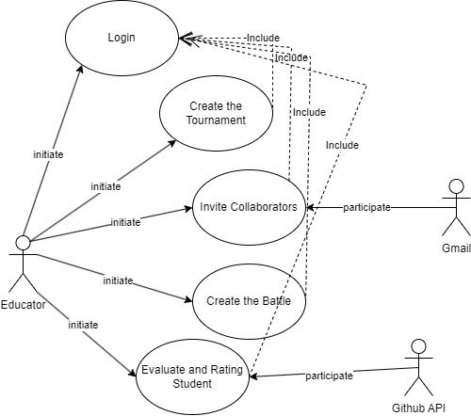
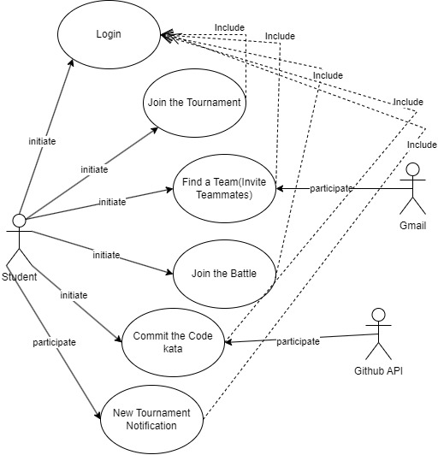
3.2.1 Use Cases Diagrams

3.2.2 Use Cases
[UC1] | Student Login
Actor | Student
Entry Condition | The student accesses the login page.
Event Flow | - The student clicks on the “Student” radio button.  - The student enters registered credentials (Email and Password).  - The student clicks on the “SIGN IN” button.  - The system validates the login information.  - The page shows the proper dashboard.
Exit Condition | The user has logged in successfully.
Exception | - The student enters incorrect credentials.  - The account has not yet been validated.

[UC2] | Student Registration
Actor | Student
Entry Condition | The student accesses the login page.
Event Flow | - The student clicks on the “SIGN UP” button.  - The student clicks on the “Student” radio button.  - The student enters email address and password.  - The student clicks on the “DONE” button.  - The system validates the sign-up information.  - The system sends a verification email to the user.  - The student verifies their email address by clicking on the provided link.  - The system displays the approval message.  - The system redirects to the login page.
Exit Condition | Registration has been successful. The student’s data will be stored in the system’s database and the student will then be able to sign into the platform.
Exception | - The provided information is incomplete or inaccurate.  - The chosen email is already in use, the system notifies the user to choose a different one.

[UC3] | Educator Login
Actor | Educator
Entry Condition | The educator accesses the login page.
Event Flow | - The educator clicks on the “Educator” radio button.  - The educator enters registered credentials (Email and Password).  - The educator clicks on the “SIGN IN” button.  - The system validates the login information.  - The page shows the proper dashboard.
Exit Condition | The educator has logged in successfully.
Exception | - The educator enters incorrect credentials.  - The account has not yet been validated.

[UC4] | Educator Registration
Actor | Educator
Entry Condition | The educator accesses the login page.
Event Flow | - The educator clicks on the “SIGN UP” button.  - The educator clicks on the “Educator” radio button.  - The educator enters email address and password.  - The educator uploads the Teacher’s Certificate.  - The educator clicks on the “DONE” button.  - The system validates the sign-up information.  - The system checks for certificate validation (within 24 hours).  - The system sends a verification email to the user.  - The educator verifies their email address by clicking on the provided link.  - The system displays the approval message.  - The system redirects to the login page.
Exit Condition | Registration has been successful. The educator’s data will be stored in the system’s database and the educator will then be able to sign into the platform.
Exception | - The provided information is incomplete or inaccurate.  - The certificate is invalid.  - The chosen email is already in use, the system notifies the educator to choose a different one.

[UC5] | Creates a Tournament
Actor | Educator
Entry Condition | The educator is logged into the CKB platform.
Event Flow | - The educator accesses the CKB platform.  - The educator navigates to the tournament creation section by clicking on the “Create Tournament” button.  - The system displays a form for creating a tournament.  - The educator configures tournament settings, such as tournament name and rules, badges definitions and variables associated with the tournament, and sets the deadline for student subscriptions to tournaments.  - The educator clicks on the “Join” button.  - The system displays the message of approval of the addition of the battle.  - The educator clicks on the “Create” button.  - The system displays a Confirm message.  - The educator clicks on the “Confirm” button.  - The system displays the message of approval for the creation of the tournament.  - The system sends an email to all student users on the CKB platform notifying them that a new tournament has been created.  - The system redirects to the tournament page.
Exit Condition | The tournament is successfully created, and students are notified of the new tournament.
Exception

[UC6] | Creates a Battle
Actor | Educator
Entry Condition | - The educator is logged into the CKB platform.  - The educator has the necessary permissions to create a battle.  - The tournament in which this battle is taking place is in progress.
Event Flow | - The educator accesses the CKB platform.  - The educator navigates to the Tournaments Section.  - The educator selects the tournament in which to create a battle  - The educator clicks on the “Create Battle” button.  - The system displays a form for creating a battle.  - The educator enters the name of the tournament name of the battle.  - The educator enters the details of the battle, including its name and rules, sets the deadline for student submissions and subscriptions to battle, the number of the team member, uploads the problem and the test cases, and adds compiles.  - The educator clicks on the “Join” button.  - The system displays the message of approval for the creation of the battle.  - The system sends an email to all student users on the CKB platform and educator users with permission to create battles at this tournament, notifying them that a new battle has been created.  - The system redirects to the battle’s tournament page.
Exit Condition | The battle is successfully created, and students and educators subscribed to the current tournament are notified of the new battle.
Exception | - The educator is not authorized to create battle in the current tournament.  - The tournament in which this battle is taking place is ended.  - The tournament does not exist.

[UC7] | Subscribes to a Tournament
Actor | Student
Entry Condition | - The student is logged into the CKB platform.  - The tournament is open for subscription.
Event Flow | - The student accesses the CKB platform.  - The student navigates to the list of unsubscribed tournaments.  - The student subscribes to a specific tournament by clicking on the “participate” button.  - The system displays the approval message.  - The system redirects to the battle’s tournament page.
Exit Condition | The student is successfully subscribed to the tournament.
Exception | The tournament subscription deadline has passed.

[UC8] | Subscribes to a Battle
Actor | Team
Entry Condition | - The team members are logged into the CKB platform.  - The team members have joined the tournament to which the current battle belongs.  - The battle is open for subscription.  - The number of registered teams is not full.
Event Flow | - The team member accesses the CKB platform.  - The team member navigates to the Tournaments Section.  - The team member selects the specific tournament which the battle belongs.  - The system displays the list of ongoing battles.  - The team member selects and subscribe for a battle by clicking on the “register” button.  - The team member clicks on the “Join the Battle” button.  - The system displays the approval message.  - The system redirects to the battle page.
Exit Condition | The team is successfully subscribed to the battle.
Exception | - The deadline for subscripting to the tournament has ended.  - The number of registered team is full.

[UC9] | Join an Existing Team
Actor | Student
Entry Condition | - The student is logged into the CKB platform.  - The student is associated with the specific battle.
Event Flow | - The user accesses the CKB platform.  - The user navigates to the Battles Section.  - The user selects the specific battle for which they want to join the team for.  - The student clicks on the “Join an existing team” button.  - The system displays the team search input box.  - The student enters team name.  - The student clicks on the “join” button.  - The system displays the approval message to join of the team.
Exit Condition | The student is successfully joined to the battle.
Exception | - Application to join the team rejected.  - The team is full.  - The deadline for subscripting to the battles has ended.

[UC10] | Student Create a New Team
Actor | Student
Entry Condition | - The student is logged into the CKB platform.  - The student is associated with the specific battle.
Event Flow | - The user accesses the CKB platform.  - The user navigates to the Battles Section.  - The user selects the specific battle for which they want to create a team.  - The student clicks on the “Create a new team” button.  - The system displays the Create Team form.  - The student completes the team information (the name of the team and the number of members).  - The student clicks on the “register” button.  - The system displays the approval message to create the team.
Exit Condition | The student is successfully created the battle.
Exception | The team's name already exists.

[UC11] | Grant Permission to Create Battles
Actor | Educator
Entry Condition | - The educator is logged into the CKB platform.  - The educator is the administrator of the current tournament.
Event Flow | - The educator accesses the CKB platform.  - The educator navigates to the Tournaments Section.  - The educator selects the tournament in which to grant permission to create battles.  - The educator clicks on the “Set Parameters” button.  - The educator grants permission to specific colleagues by providing their email address or selecting them from a list of registered educators.  - The educator clicks on the “Confirm” button.  - The system displays the approval message.  - The system redirects to the tournament page.
Exit Condition | The educator has successfully granted the permissions to colleagues.
Exception | Incorrect email address.

[UC12] | Invitation to Battle
Actor | Student
Entry Condition | - The student is logged into the CKB platform.  - The student is associated with the specific battle.
Event Flow | - The student accesses the CKB platform.  - The student navigates to the ongoing code kata battle in which they are participating.  - The student clicks on the “Invite” button.  - The student invites others by providing their email address.  - The student may include a personalized message along with the invitation.  - The system sends invitations to the specified students, notifying them of the invitation to join the code kata battle.  - The invited students receive notifications and can accept or decline the invitation.
Exit Condition | The student has successfully invited other students to join the team for the battle.
Exception | - Incorrect email address.  - Invited students declining the invitation.  - Maximum team size exceeded.  - The deadline for subscripting to the battle has ended.

[UC13] | Closes a Tournament
Actor | Educator
Entry Condition | - The educator is logged into the CKB platform.  - The educator is the administrator of the current tournament.
Event Flow | - The educator accesses the CKB platform.  - The educator navigates to the Tournaments Section.  - The educator selects the specific tournament they want to close.  - The educator clicks on the “Close” button.  - The system displays a Confirm message.  - The educator clicks on the “Confirm” button.  - The system displays the message of approval for the end of the tournament.  - The system performs final calculations for the tournament, including generating the final tournament rank based on individual battle scores.  - The system evaluates the rules and assigns tournament badges to eligible students.  - The system notifies all students involved in the tournament of the closure and provides access to the final tournament rank.
Exit Condition | The tournament is successfully closed.
Exception | - The tournament is incomplete (e.g., ongoing battles).  - The educator doesn’t have the necessary permission to the close the tournament.

[UC14] | Views User Profile
Actor | User (Student or Educator)
Entry Condition | The user is logged into the CKB platform.
Event Flow | - The user accesses the CKB platform.  - The user navigates to the Profile Section.  - The user can view their own profile details, including personal information, tournament scores, and badges earned.  - If the user wishes to view another user’s profile:  - The user initiates a search for the specific user by entering their email address.  - The system retrieves and displays the profile information of the selected user.
Exit Condition | The user has successfully viewed the desired profile information.
Exception | Profile not found.

[UC15] | Views Battle Rankings
Actor | User (Student or Educator)
Entry Condition | The user is logged into the CKB platform.
Event Flow | - The user accesses the CKB platform.  - The user navigates to the Battles Section.  - The user selects the specific battle for which they want to view rankings.  - The system displays the current rankings, including scores and positions of all participating teams or individuals.  - The user can navigate through different sections of the rankings, such as overall rankings, scores for specific evaluation criteria, and individual battle scores.
Exit Condition | The user has successfully viewed the desired battle rankings and related information.
Exception

[UC16] | Views Tournament Rankings
Actor | User (Student or Educator)
Entry Condition | The user is logged into the CKB platform.
Event Flow | - The user accesses the CKB platform.  - The user navigates to the Tournament Section.  - The user selects the specific tournament for which they want to view rankings.  - The system displays the current overall rankings, including aggregated scores and positions of all participating tournament.  - The user can navigate through different sections of the rankings, such as individual battle scores, badges earned, and other relevant information.
Exit Condition | The user has successfully viewed the desired tournament rankings and related information.
Exception

[UC17] | Participates in Practice Mode
Actor | Student
Entry Condition | - The student is logged into the CKB platform.  - The code kata battle has ended.
Event Flow | - The student accesses the CKB platform.  - The student navigates to the Practice Section.  - The system presents a list of available code katas or programming exercises for practice.  - The student selects a specific code kata from the list.  - The system provides a description of the selected code kata, including requirements, constraints, and any provided code snippets or templates.  - The student starts working on the code kata by writing code to meet the specified requirements.  - The student completes the code kata and submits their solution to the system for evaluation.  - The system automatically assesses the solution, score, providing feedback on correctness, efficiency, and best practices.  - The student reviews the evaluation feedback and may choose to revisit and improve their solution.
Exit Condition | The student successfully completes the selected code kata in practice mode.
Exception | The battle is still in progress and practice mode is not available.

[UC18] | Manual Evaluation
Actor | Educator
Entry Condition | - The educator is logged into the CKB platform.  - The educator is the administrator of the current battle.  - The battle has reached the consolidation stage where manual evaluation is required.
Event Flow | - The educator accesses the CKB platform.  - The educator navigates to the Battle Section.  - The educator selects the specific battle for which manual evaluation is required.  - The educator clicks on the “Evaluation” button.  - The system provides a list of teams or individuals participating in the battle, along with their submitted work.  - The educator reviews the source code, test cases, and other relevant materials submitted by each team or individual.  - The educator assigns scores of feedback based on predetermined evaluation criteria, such as code quality, adherence to best practices, and overall completeness.  - The educator submits the final evaluations and scores for each team or individual by clicking on the button “Submit”.  - The system displays the approval message.  - The system redirects to the battle page with the team list.
Exit Condition | The educator has successfully completed the manual scoring of the battle and the scores are recorded in the system.
Exception

[UC19] | Commits Code Kata
Actor | Student
Entry Condition | - The student is logged into the CKB platform.  - The student is enrolled in a specific code kata battle or practice mode session.
Event Flow | - The student accesses the CKB platform.  - The student navigates to the Battle Section or Practice Mode Section.  - The student selects the specific battle for which want to commit the solution.  - The student initiates a commit by pushing their code changes to the main branch of the associated repository.  - The system detects the new commit.  - The system retrieves the latest source code from the repository.  - The system performs automatic analysis of the code by using “SonarQube” API.  - The system updates the scores for the student based on the results of the automatic evaluation.  - The student receives feedback on the evaluation, including scores, information on test case outcomes, code quality, and other relevant criteria.
Exit Condition | The student is successfully committed the code kata solution.
Exception | Commits code after the submission deadline.
3.2.3 Sequence Diagrams
UC1 – Login as Student
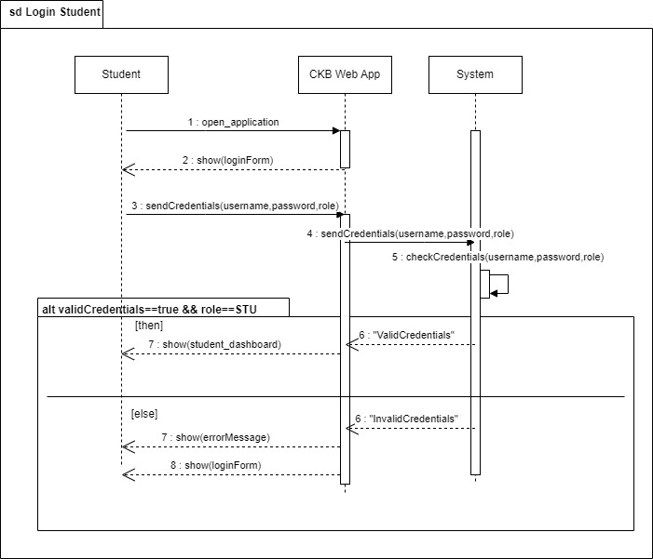
UC-2 Sing up as Student
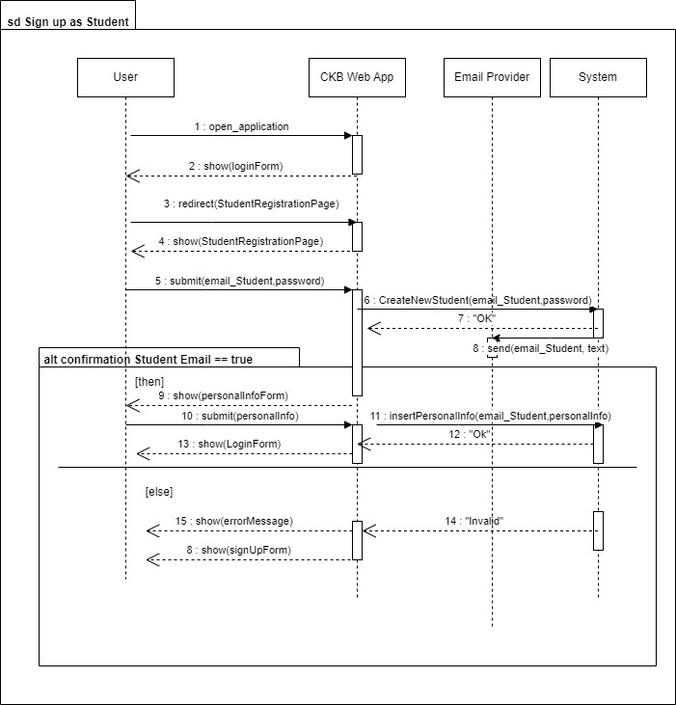
UC-3 Login as Educator
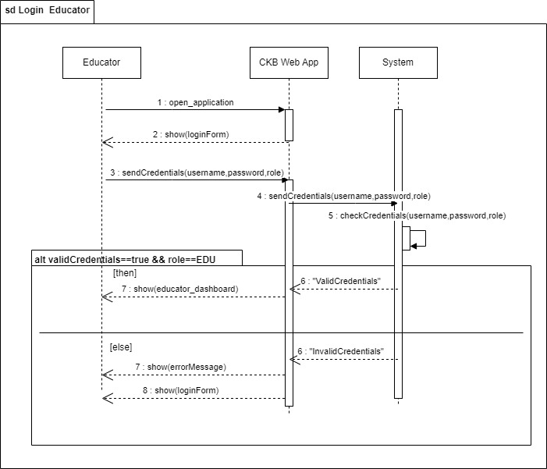
UC-4 Sign up as Educator
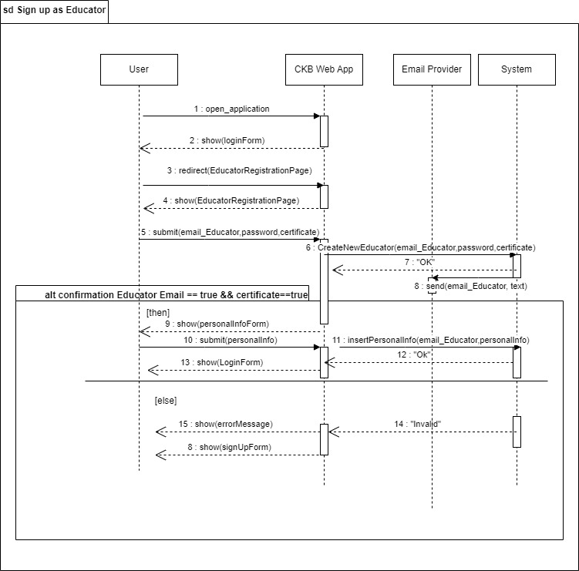UC- 5 Creates Tournament
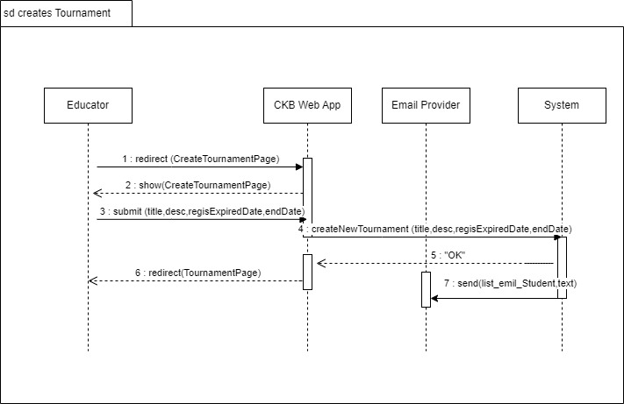
UC-6 Creats Battle
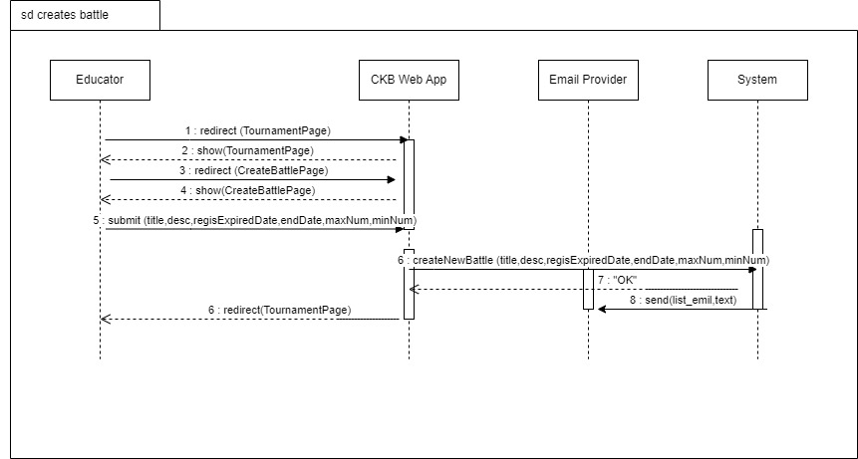
UC-7 Subscribes to a Tournament
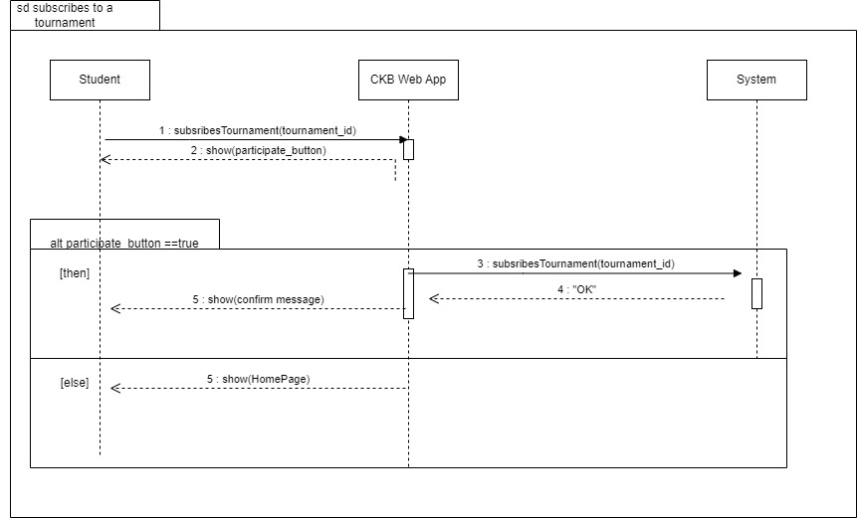
UC-8 Subscribers to a Battle
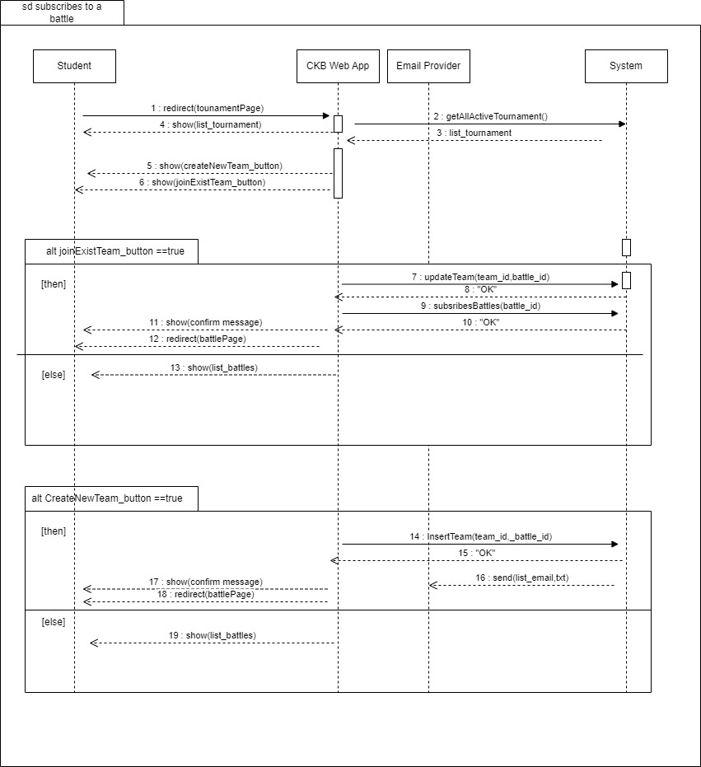
UC-9 Join an Existing Team
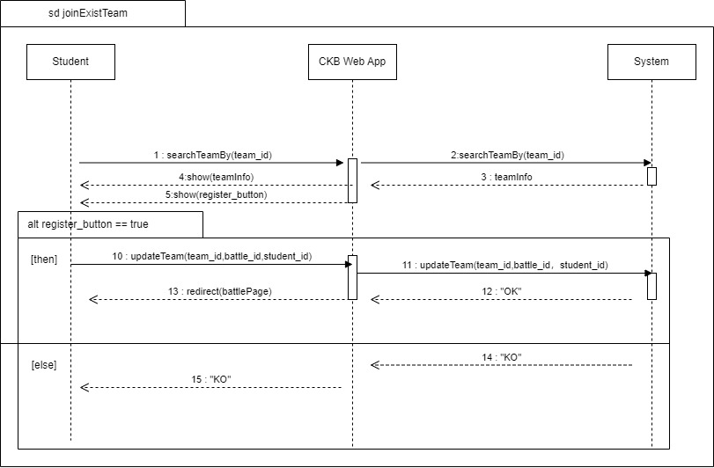
UC-10 Create a New Team
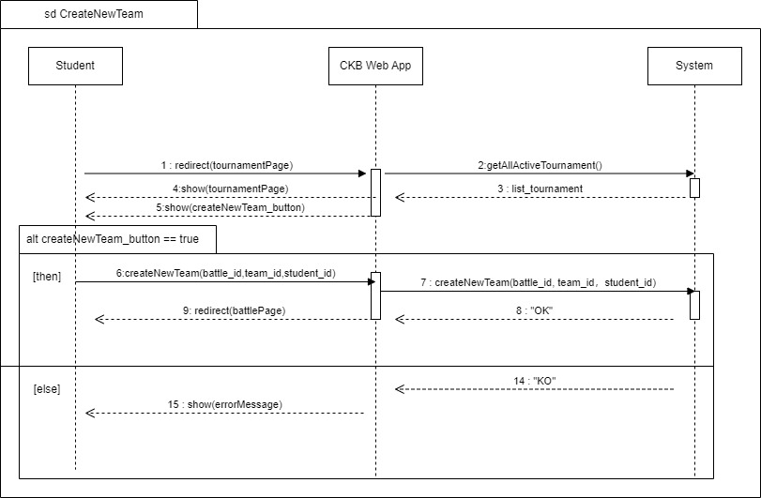
UC-11 Granting Permission
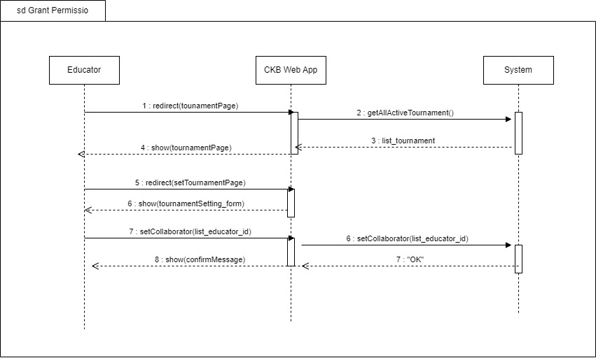
UC-13 Close Tournament
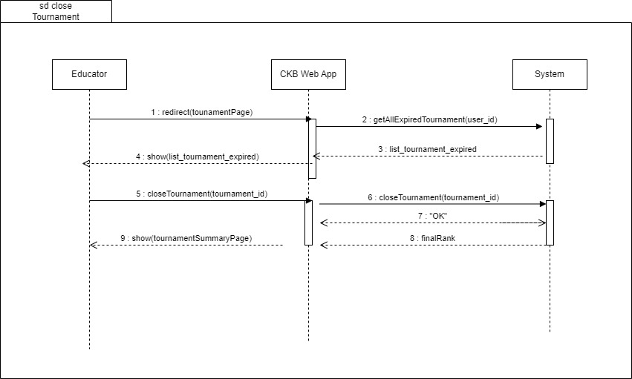
UC-14 View profile

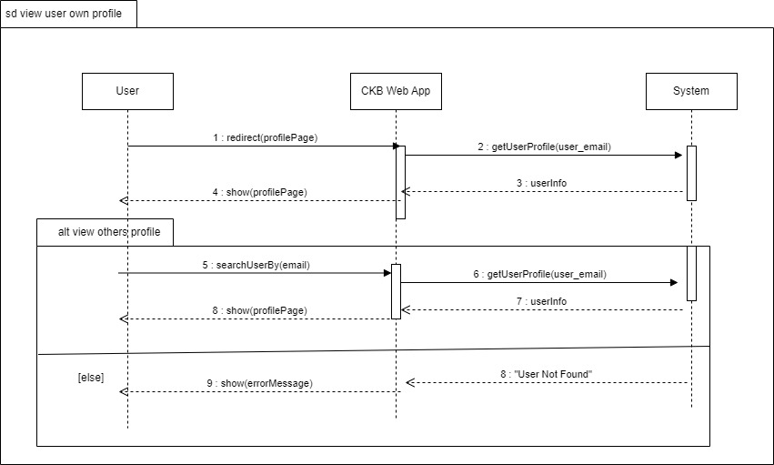
UC-15 View Battle Ranking
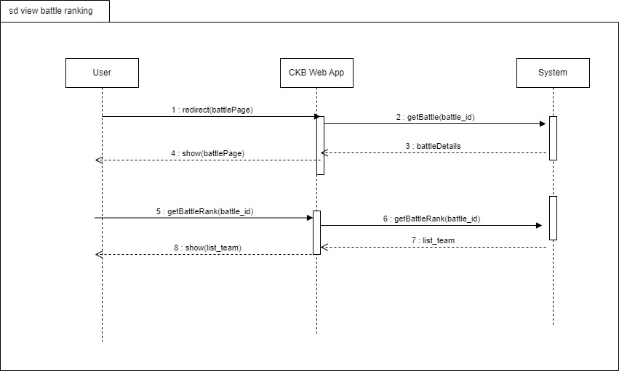
UC-16 View Tournament Ranking
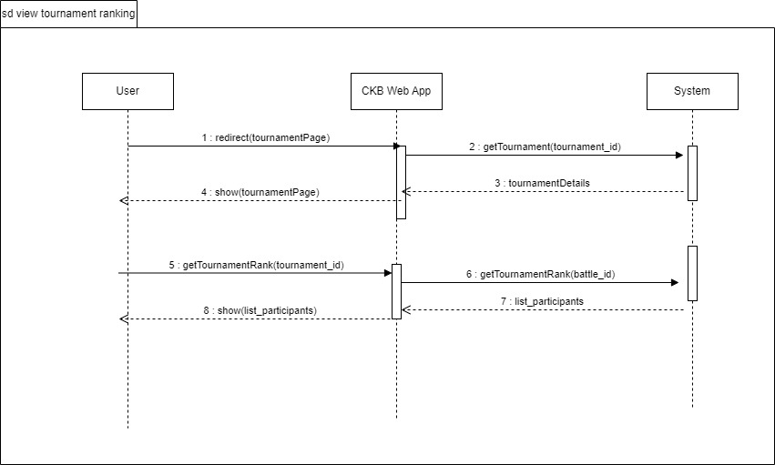
UC-17 Practice Mode
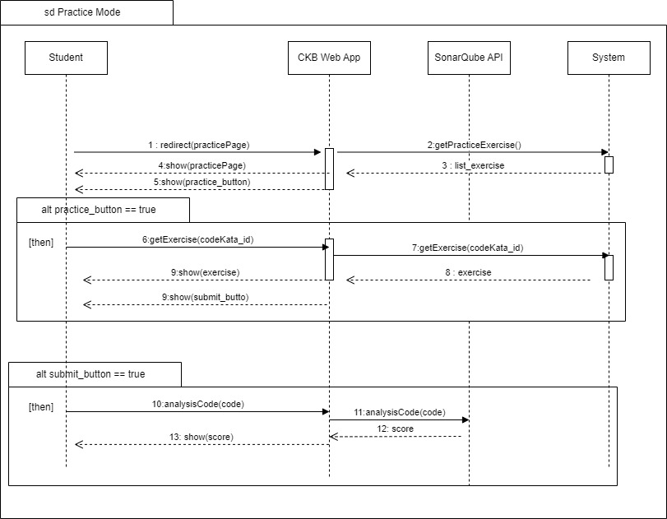
UC-18 Manual Evaluation
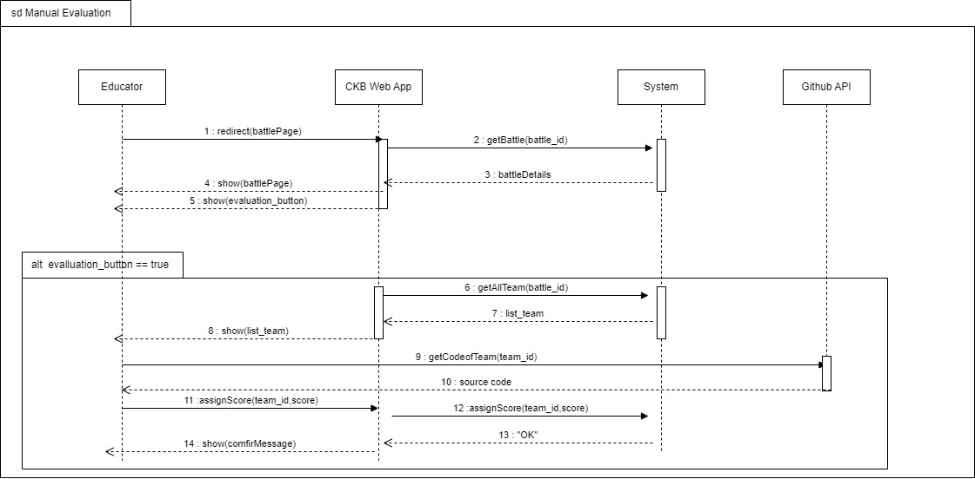
UC-19 Commits Code Kata
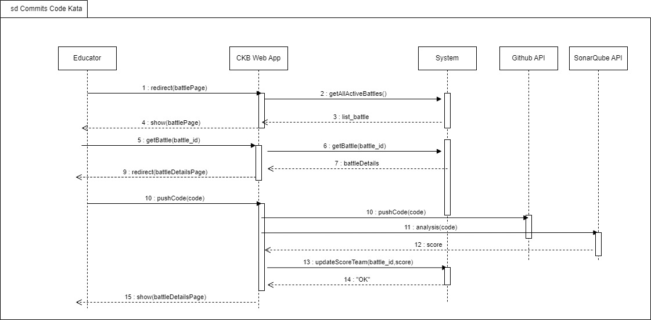
3.2.4 Requirements Mapping
[G1] Allows Students to select a language for training
[R1] The system allows Students to sign up.  [R2] The system allows Students to sign in.  [R5] The system allows Students to access the profile section.  [R7] The system allows Students to choose their preferred programming language.  [R16] The system allows Students to access a comprehensive list of battles in which they have previously participated. | [D1] The CKB platform assumes that users have a stable internet connection to access and interact with its features.  [D5] Users must undergo a secure authentication phase during the login process to access the CKB platform.

[G2] Allows Students to subscribe to tournament and battles.
[R6] The system allows Students to send invitations for specific battles.  [R8] The system allows Students to explore and view details of individual tournaments.  [R9] The system allows Students to subscribe to tournaments.  [R10] The system allows Students to explore and select specific battles with tournaments.  [R11] The system allows Students to subscribe to battles.  [R13] The system allows Students to view their scores obtained in battles.  [R14] The system allows Students to access battle raking.  [R15] The system allows Students to access tournament ranking.  [R34] The system allows Students to invite other students to join the team for the battle. | [D1] The CKB platform assumes that users have a stable internet connection to access and interact with its features.  [D2] Once the registration deadline for tournaments or battles has passed, students cannot register for any ongoing or upcoming events.  [D4] The system must ensure a necessary timestamp between the end of the last battle of a tournament and the conclusion of that tournament.  [D6] CKB relies on access to GitHub functionality for its features to operate effectively.  [D8] The platform is expected to deliver notifications to users within a time frame of one minute.  [D11] Students must respect to the specified maximum and minimum number of group members when forming teams for battles.  [D12] Each student is expected to participate in a single team for a specific battle, promoting fairness and avoiding potential conflicts of interest.

[G3] Allows Educators to create tournaments and battles
[R18] The system allows Educators to create new tournaments.  [R19] The system allows Educators to create new battles.  [R20] The system allows Educators to grant specific individuals the authority to create battles within a tournament.  [R21] The system allows Educators to setting titles and rules for tournaments, referred to as “Tournament Badges”.  [R22] The system allows Educators to upload code kata with referenced answer.  [R24] The system allows Educators to set participant limits, registration deadlines and submission deadlines for each battle.  [R25] The system allows Educators to configure grading parameters (e.g. security percentages...).  [R29] The system notifies Educators and Students once the tournament has concluded.  [R30] The system notifies Educator and Students once the battle has concluded.  [R32] The system allows Educators to access to the code submitted by Students through GitHub commits.  [R33] The system allows Educators to send manual scores to the platform. | [D1] The CKB platform assumes that users have a stable internet connection to access and interact with its features.  [D3] After the deadline of a tournament, no new battles can be created within the scope of that tournament.  [D4] The system must ensure a necessary timestamp between the end of the last battle of a tournament and the conclusion of that tournament.  [D7] Educators can only rate student submissions after the submission deadline has passed.  [D10] Each badge earned by a student is associated with a specific tournament, reflecting the achievements within that context.  [D11] Students must respect to the specified maximum and minimum number of group members when forming teams for battles.

[G4] Allows Students to practice their coding skills with code kata battles
[R12] The system notifies Students of a GitHub repository link associated with the selected battle.  [R23] The system allows Students to access referenced answer.  [R26] The system notifies Students upon the creation of a new tournaments.  [R27] The system notifies Students upon the updates of a new battle.  [R28] The system notifies Students in advance of upcoming battles.  [R31] The system notifies Students of the battle results and the overall tournament results, including scores and rankings. | [D1] The CKB platform assumes that users have a stable internet connection to access and interact with its features.  [D2] Once the registration deadline for tournaments or battles has passed, students cannot register for any ongoing or upcoming events.  [D4] The system must ensure a necessary timestamp between the end of the last battle of a tournament and the conclusion of that tournament.  [D6] CKB relies on access to GitHub functionality for its features to operate effectively.  [D8] The platform is expected to deliver notifications to users within a time frame of one minute.  [D9] The overall tournament score is the sum of scores from all individual battles within that tournament.  [D10] Each badge earned by a student is associated with a specific tournament, reflecting the achievements within that context.

[G5] Allows Students to practice in offline mode
[R17] The system allows Students to choose the practice mode for ongoing learning and skill enhancement. | [D1] The CKB platform assumes that users have a stable internet connection to access and interact with its features.  [D9] The overall tournament score is the sum of scores from all individual battles within that tournament.

3.3 Performance Requirements
To ensure the CodeKataBattle (CKB) platform delivers a responsive, reliable, and scalable user experience, the following performance requirements are defined:

3.3.1 Response Time
- User Interaction:
  - The system must respond to user interactions (e.g., code submissions, page loading) within 2 seconds under normal operating conditions.
- Code Compilation:
  - Code compilation processes should complete within 10 seconds for small to medium-sized projects. Larger projects may have varying compilation times, but the system aims to optimize and minimize latency.
3.3.2 Concurrent Users
- Concurrency Handling:
  - The platform must support a minimum of 500 concurrent users without significant degradation in performance. This includes users participating in code kata battles, accessing profiles, and engaging in real-time interactions.
3.3.3 Scalability
- User Growth:
  - The system should be designed to handle a growth in user base by at least 20% per year. Scalability considerations should be in place to accommodate additional users without compromising performance.
- Battle and Tournament Scalability:
  - The platform must efficiently scale to support an increasing number of battles and tournaments. This includes optimizing database queries, resource allocation, and load balancing mechanisms.

3.5.4 Reliability and Availability
- System Uptime:
  - The platform must maintain a minimum of 99.5% uptime over a rolling 12-month period, excluding scheduled maintenance windows. This ensures users have reliable access to the system.
- Fault Tolerance:
  - The system should be designed with fault-tolerant mechanisms to handle unexpected failures or disruptions, minimizing downtime and ensuring continuity of service.
3.5.5 Data Throughput
- Submission Processing:
  - The system should be capable of processing a minimum of 100 code submissions per minute during peak usage periods.

- Email Notifications:
  - Email notifications to users, such as tournament announcements, should be sent promptly, with an average delivery time not exceeding 1 minute.
These performance requirements are crucial for providing a seamless and efficient experience for users on the CodeKataBattle platform. Regular performance monitoring and optimizations will be conducted to meet or exceed these specifications.
3.4 Design Constraints
3.4.1 Standards Compliance
The CKB platform adheres to various standards to ensure compatibility, security, and best practices in software development.
- Coding Standards:
  - All code generated and submitted on the platform must adhere to widely accepted coding standards in the respective programming languages (e.g., Java, Python). This ensures consistency and readability.
- Security Standards:
  - The platform complies with industry-standard security practices to protect user data, including secure transmission of information and secure storage of credentials. It follows encryption protocols and secure authentication mechanisms.
- Web Standards:
  - The user interfaces and interactions follow web standards to ensure cross-browser compatibility, accessibility, and responsiveness. This includes adherence to HTML, CSS, and JavaScript standards.
- Privacy Regulations:
  - The platform complies with relevant data protection and privacy regulations, ensuring that user data is handled responsibly and ethically. It provides mechanisms for users to control their privacy settings.
3.4.2 Hardware Limitations
The CKB platform operates within specific hardware limitations to ensure optimal performance and resource utilization.
- Minimum System Requirements:
  - Users accessing the platform are required to have devices that meet minimum system requirements, including a compatible web browser and sufficient processing power to handle coding tasks.
- Network Connectivity:
  - The platform relies on network connectivity for user access and data exchange. Users must have a stable internet connection to use CKB effectively.
- Scalability:
  - While efforts are made to optimize platform performance, there are inherent hardware limitations that may impact scalability. The system is designed to handle a reasonable number of simultaneous users, and scalability considerations are continuously monitored.
- Compatibility with Development Tools:
  - Users are encouraged to use up-to-date development tools and environments that are compatible with the platform. Compatibility issues with outdated tools may impact the user experience.
These design constraints are essential to maintaining the integrity, security, and performance of the CodeKataBattle platform. Continuous monitoring and updates are conducted to adapt to evolving standards and ensure a seamless user experience.
3.5 Software System Attributes
3.5.1 Reliability
The system has to be able to run continuously without any interruptions for long
periods. To be fault-tolerant the system backend deployment must take advantage of
some sort of replication and redundancy. The system has to have offline backups of
the data storage to exploit in disaster recovery after a data loss.
3.5.2 Availability
Given the fact that CKB is not an emergency service or anything related to critical
situations, the system must provide availability of 99.9%. This means that the
average time between the occurrence of a fault and service recovery (MTTR) has to
be contained at around 0.365 days per year.
3.5.3 Security
The system stores some sensitive personal information about users, so the security aspect
cannot be under- estimated. The central database must be protected with all the
available measures to avoid any external or internal attack. The passwords inside
the data store have to be encrypted and in case of password recovery, this must
never be sent in clear. To communicate over the internet CKB must use some sort of encryption to avoid
traffic sniffing and spoofing, thus avoiding cheating attacks and guaranteeing privacy
and consistency.
3.5.4 Maintainability
The system must guarantee a high level of maintainability. Appropriate design
patterns should be used, together with good standards. The code must be well
documented and hard-coding must be avoided. A testing routine has to be provided
and it has to cover at least 75% of the entire codebase, excluding interface code.
3.5.5 Portability
The web application must run on any OS (like Windows, Mac OS, Linux, etc) that supports a web browser.

